
Koneru Lakshmaiah Education Foundation
(Deemed to be University estd. u/s. 3 of the UGC Act, 1956)
Off-Campus: Bachupally-Gandimaisamma Road, Bowrampet, Hyderabad, Telangana - 500 043. Phone No: 7815926816, www.klh.edu.in

STUDENT CASE STUDY EXECUTION REPORT
Department | FED
Subject | DSA-2
Academic Year | 1-111 Semester | 2025-26
Faculty Name | Mohd. Razia Alangir Banu
Student Name | M. Shravya
Roll Number | 2520030588
Branch | CSE
Course Outcome | CO 5
Case Study Topic: Large-Scale Certification Data Analysis using Radix Sort
Work Done Summary:
In this case study, we implemented the Radix Sort Algorithm to efficiently organize and analyze thousands of certificate numbers and student IDs in the Skill Bridge – Online Skill Development & Certification Platform. Radix Sort was chosen because it can sort large numeric datasets efficiently without performing direct element comparisons, making it suitable for certification management systems.

Implementation Details:

1 Stored certificate numbers and student IDs in arrays.
2 Implemented Radix Sort using digit-by-digit sorting.
3 Applied Counting Sort as a subroutine for each digit position.
4 Sorted thousands of certificate records efficiently.
5 Compared Radix Sort performance with traditional comparison-based sorting algorithms.
6 Generated ordered certification reports for quick retrieval and verification.
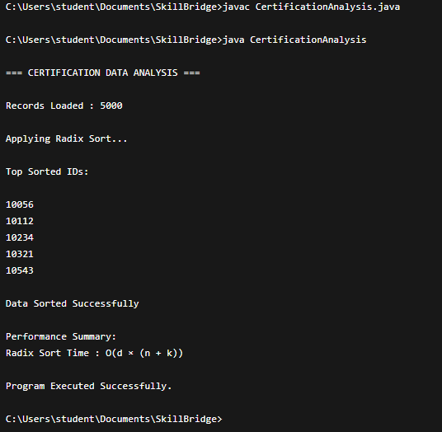

Result: Screenshots / Output

Time Complexity:
Operation | Complexity
Radix Sort | O(d × (n + k))
Counting Sort (per digit) | O(n + k)
Data Loading | O(n)
Output Generation | O(n)
Where:
- n = Number of certificate records
- d = Number of digits in the largest ID
- k = Range of digit values (0–9)

Result
The Radix Sort Algorithm efficiently sorted thousands of certificate numbers and student IDs with high performance and scalability. The system successfully organized certification records, enabling faster searching, reporting, and verification processes within the Skill Bridge platform.

GitHub Link:

Student Signature Faculty Signature

